Persona Expectations

Requirements

Definition

CS522-Mobile Systems and Applications  
Cell: 917-587-8550  
Email: Luckin89@gmail.com

Mar. 29th 2012

CS522 Mobile Systems and Applications

Yang Wang

* They want to have a convenience way to collect patients’ information, includes audio & video health data and geolocation information.
* They want to view patients’ information on mobile platform.
* They want to make a visit plan based on the patients’ location.
* They want to communication among the community health workers.

From the users’ expectations we could see that we need following function in application,

1. Client Interface, use to collect the patients’ information.
2. Data Base, divide into two parts: one stores the health information in local storage (or maybe aggregate to the web server), another on the cloud that could send the control information (such as location information, health data status etc.) used for the “control plane”.
3. CHW’s interface, use to get the patients information, track the users’ locations to navigating CHWs to those patients and communication with other CHWs exchange patient data on cloud.

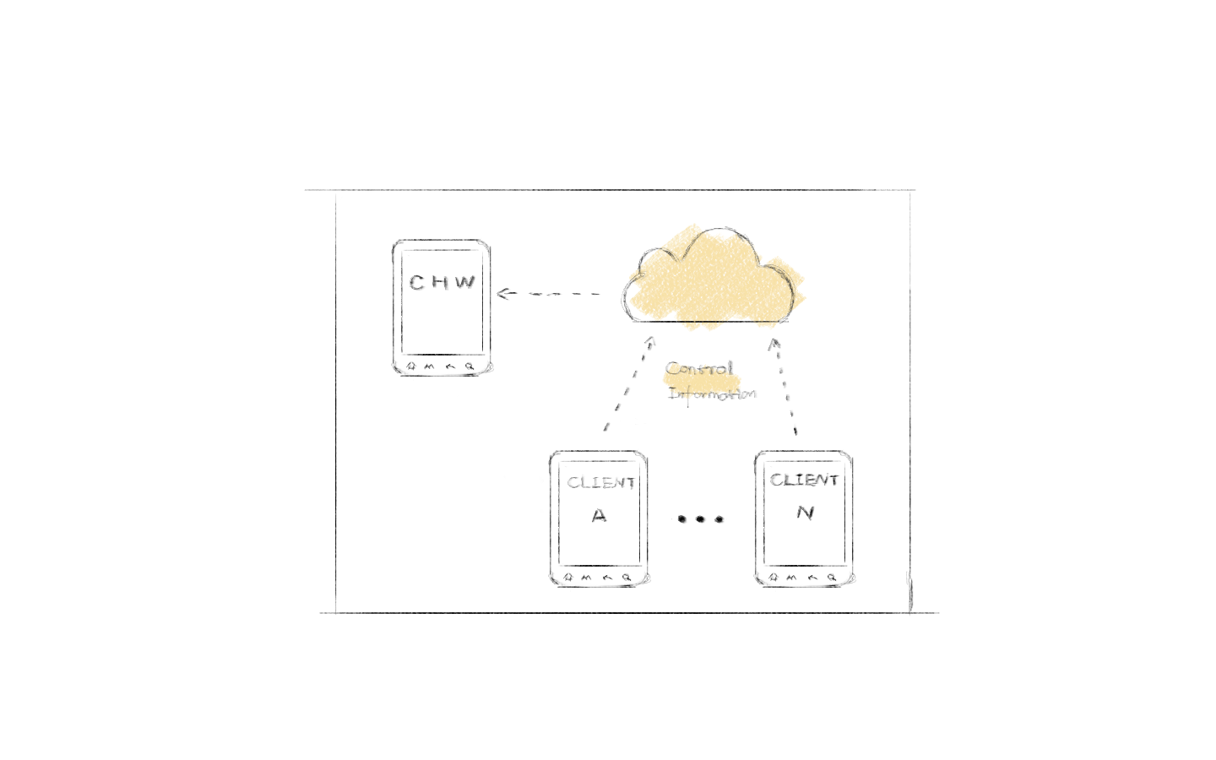

Figure Process of information communication

The goals of primary persona are:

1. Conveniently gather patients’ information.
2. Track patients’ location.
3. Communication with other CHWs and exchange patients’ information.

Context Scenario

1. While getting ready in the morning, Jennifer uses her phone to check the notification of patients’ information status. The application already **received the notification** and Jennifer only need **click them to download**, it is more **convenient than booting up a computer** as she rushes to make her two daughters, Eva and Emma, sandwiches for school.
2. After Jennifer sent her daughters to school, the application has downloaded the newest patients’ information. Then Jennifer **sees a message from her colleague**, Ryan, he sends **a patient’s information** to her whom he talked about yesterday, he needs Jennifer to share the experience with him and take care of the patient together.
3. The application received the information about the patient and **added the patient to Jennifer’s list** by Jennifer’s permission, then **updated the Google map** not only the patients’ location and the **visit route** though all the patients Jennifer has. It is the visit plan, which she made this Monday, she want to visit her patients as usual.
4. She went to office gather the medical kit and other document she needs, then she start the trip, during yesterday’s evening the application had **send the appointment** with the patients who need to get medical treat, each patient at different time scale according to the location. While driving on the road the application **navigate Jennifer to each patients** who accepted the appointment by drawing the route on maps.
5. While she arriving at first patient, Linda’s location the application will **adjust the time schedule** with other patients, if they want they could change their appointment with Jennifer. Jennifer talk with Linda about her health according to the information she downloaded this morning, and take the routine test about her then she give Linda some medicine and instruction.
6. After Jennifer get out of Linda’s house, she found one of her patients has been visited by other CHW, Frank, hence she just deleted the patient from her today’s visit list and **updated the map manually**. The rest day goes normally and after she going home, her husband Steven has taken their daughters back home from school. She **uploads the diagnosis information** of each patient she visited to the cloud.
7. While Jennifer taking shower, Ryan send a message that says he has sees the information, which Jennifer updated and ask whether she want to visit the patient, Vivien, whose information has been sent to her next Monday. Jennifer **accepts the appointment** and the **application send an appointment** to Vivien automatically with the signature “Yours, Ryan and Jennifer”.
8. Jennifer go to bed tomorrow she and family will go to the beach to see sunrise, so get some sleep and have nice dream!

Requirements

Instruction: Objects, Actions and Contexts.

1. Receive the notification and download the health information from patients.
2. Send messages and patients’ information to other CHWs.
3. Added a patient to CHW’s list.
4. Update the Google map according to the patients’ location.
5. Send appointment to patients.
6. Navigate CHWs to each patient.
7. Update the Google map manually by CHWs.
8. Uploads the diagnosis information to the cloud.